You can insert English title here with title case format and don’t use automatic heading styles

First AUTHOR*^{1,a}, Second AUTHOR^{2,b}, Third AUTHOR^{3,c}
¹Gümüşhane University, Engineering and Natural Sciences Faculty, Department of Geological Engineering, 29100, Gümüşhane
²Karadeniz Technical University, Engineering Faculty, Department of Civil Engineering, 61080, Trabzon

Abstract
The body text must be prepared in the font of Times New Roman at 11 points font size, justified, single space and without indentations. The abstract must not exceed 2000 characters. There should be no space between the “Abstract” heading and abstract body text. Keywords have to be in alphabetical order. Minimum number of keywords should be 3 and maximum number should be 6. All authors have to state their ORCID numbers and the corresponding author has to state his/her contact details.

Keywords: First Word, Second Word, Third Word (minimum 3 maximum 6 words with alphabetical order)

1. Introduction

You can prepare your article (titles, abstract, body text, etc.) on this template without changing the formatting.

The page size should be in A4 format, the number of pages should be no more than 15 and the margins should be given by leaving a space of 2 cm from all edges. Page numbers should be given at the bottom and center of the page. The page number must have Times New Roman font type and must have 11 points of font size. Line numbers, on the other hand, should be numbered "continuously" starting from the first page of the article (restart and/or restart features should not be used on each page). All line spacing must have Times New Roman font type and must have the font size of 11 points. The main text should be set to the size of "11 points" and "justified" and the key level as "body text" should have the character of "Times New Roman". There should be no right and left line indentation, the range values before and after the text should be 0 nk, and the line spacing value should be written with single (1) spacing. After punctuation (period, comma, semicolon, etc.), a character space must be left. One line should be left between each paragraph and should not be started from the inside at the beginning of the paragraph (the first line indentation or tab key should not be used).

Master Headings must be numbered respectively (1. Introduction 2. Purpose, Equipment and Methods...etc). All titles should be left leaning with the font type of Times New Roman, font size of 11 point, dark and the first letter of each word capitalized. One line of space should be left before and after the main headings. Subheadings must be numbered in accordance with the main title number. All subheadings should be written in left-leaning with the font type of Times New Roman, font size of 11 point, dark, italic and the first letter of each word capitalized (2.1. Material 2.2. Preparation of Test Samples,etc). One line of space should be left before and after the subheadings.

Formats such as automatic title style, bullets, multilevel list should not be used when writing headings, instead it should be written in plain text. In body text, a space must be left between each paragraph (before and after).

References given in the text should be given as in the following example paragraph.

“……………………………………(Özsayar vd., 1981; Güven, 1993).”
The citations should be colored with the blue (RGB; 0,112,192) tint shown in Figure 1 and Figure 2.

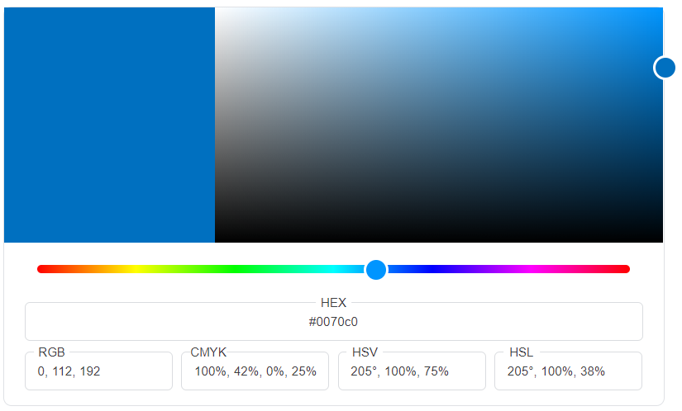

Figure 1. Tint and color codes of references given in the text.

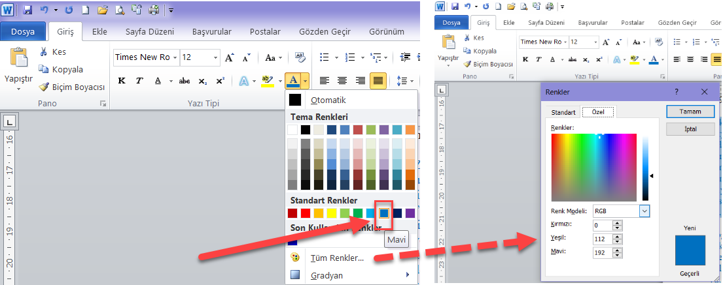

Figure 2. Tint and color codes of references given in the text.

2. Material and Methods

It is no longer necessary to even quote commonly used and known methods (such as the chi-square test) and to specify the developer. However, if some changes are made to the method used, it should be mentioned by citation. Apart from these, all units should be in metric systems, 24-hour time should be used, and dates should be specified in the form of days and months and years. Caution should be taken to use periods (.) instead of commas (,) as decimal places. This section can be given in figures if necessary.

2.1. Analysis

2.1.1. Chemical Analysis

Analytical methods can be given under one heading or, if necessary, methods and equipments can be divided into separate headings. However, when giving subheadings, left-leaning, bold and italics should be chosen.

2.1.2. Physical Methods

Analytical methods can be given under one heading or, if necessary, methods and equipments can be divided into separate headings. However, when giving subheadings, left-leaning, bold and italics should be chosen.
3. Results / Results and Discussion

The results section can be combined with the Discussion section and given in the form of Results and Discussions, depending on the type and subject of the study.

3.2. Figures and Tables

3.2.1. Figures

Figures should be clear and legible, centered so that they do not exceed page boundaries from the edges. It must be numbered in order. The figure order should be continuously starting from 1 (Figure 1, Figure 2, Figure 3, ...). Figure numbers and names should be given under the figure, leaning against the lower left edge of the figure, and only the first letter of the first word should be given in capital.

Figures must either be drawn with a drawing program or scanned at least 300 dpi resolution. Because figures created using the "drawings" toolbar in Word cause shifts during string, such figures must be created in jpeg, tiff, png, etc. formats using any drawing program other than Word. Similarly, enumeration of multiple figures (a, b, c, d, etc.) should be avoided as much as possible with the text box. Drawings and graphics from office programs such as Excel and Paint should not be pasted directly into a Word document so that the source file cannot be read, and such drawings should be drawn in a drawing program as much as possible and added in a compact form with formats such as jpeg, tiff, png and compact. The position of the figures in the document should be in the position of "Aligned with The Text" (Figure 3).

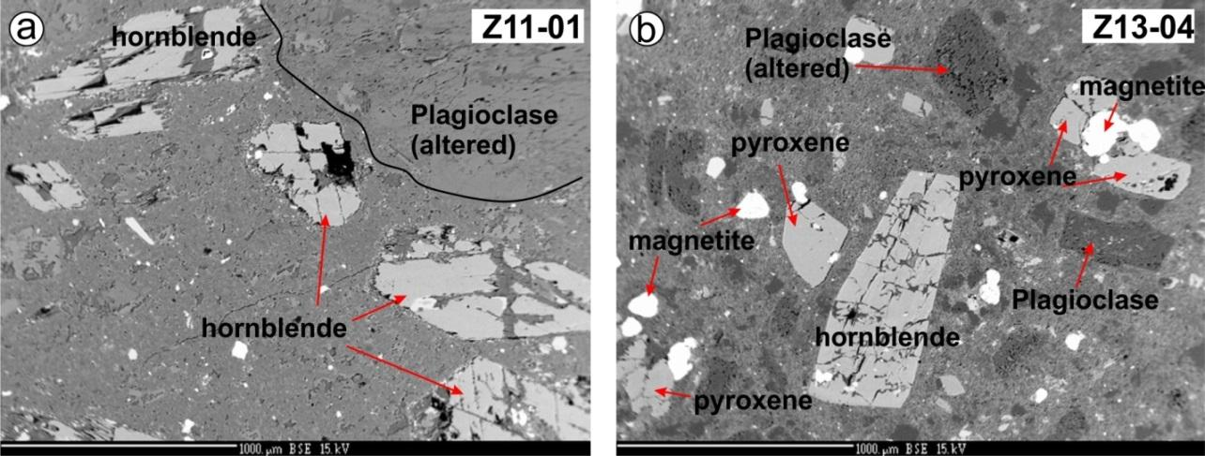

Figure 3. Figure title

The size of the text and numbers in the graphics, pictures and text boxes shown as figures should not be less than the size of 9-points written in Times New Roman character in the article. One line of space must be left before the figure, before and after the figure name as well. While placing the figures in the text, reference should be given before the figure. Automatic form type style should not be used in figure writings (in text and under related figures) and should be written in plain text.

3.2.2. Tables

Tables should be centered so that they do not exceed the page boundaries from the edges. It must be numbered in order. Table number and names should be written with a single row of space at the top left of the table, with only the first letter of the first word capitalized.

When writing the table name, one row at the top and bottom should be left, and one line of space should be left after the table. Tables should be cited in the text before the table. The figures and articles in the table rows and columns should be written in Times New Roman character and with the size of 11 points. However, in case of necessity, the font size can be reduced to at least 9 points so that it does not exceed the font limits.
Automatic form writing style should not be used in table writings (in text and related table) and should be written in plain text. Tables should not be colored unless necessary, and care should be taken to present them in a simple and understandable way. Table sorting should be continuously starting from 1 (Table 1, Table 2, Table 3, ...). As in tables and figures, care should be taken to have the text wrapping feature "in line with the text" feature (Table 1).

Table 1. Table title

The Hbl-Pl thermobarometer calculations based on Schmidt pressure values
 | Min | Mak | Ort (n=13) | Referans
P (kbar) | 3.3 | 4.2 | 3.6±0.2 | Schmidt (1992); Schmidt (1993)
T (°C) HB1 '94* | 732 | 849 | 765±29 | Holland ve Blundy (1994)
T (°C) HB2 '94** | 751 | 854 | 786±25 | Holland ve Blundy (1994)
The Hbl-Pl thermobarometer calculations based on Anderson and Smith pressure values
 | Min | Mak | Ort (=13) | Referans
T (°C) HB1* | 737 | 791 | 759±12 | Holland ve Blundy (1994)
P(kbar) HB1* | 2.0 | 3.0 | 2.4±0.2 | Anderson ve Smith (1995)
T (°C) HB2** | 747 | 791 | 768±11 | Holland ve Blundy (1994)
P(kbar) HB2** | 2.0 | 2.8 | 2.2±0.2 | Anderson ve Smith (1995)
*HB1’94, Holland ve Blundy (1994) Hbl-Pl thermometer calibration reaction: edenite + 4 quartz = thremolite + albite
**HB2’94, Holland ve Blundy (1994) Hbl-Pl thermometer calibration reaction: edenite +albite=rihterite+anortite

3.3. Equations and Symbols

3.3.1. Equations

Equations to be written in the text should preferably be written in plain text (equations 1-4) or using the MathType editor. It can also be written with the equation editor in the Word program. Equations should be written left aligned in the article, numbered in parentheses on the right side of the page. Equation font type should be in the same font and size of the text. In compulsory situations, the text size can be given as 10 or 9 points. Equations should be cited within the text.

Edenite + Albite = Rihterite+ Anorthite (1)

T = (0.677P-48.98+Y)/(-0.0429 – 0.008314LnK) (2)

Y= 0 for X_{Ab} > 0.5 and Y= -8.06 + 25.5 (1- X_{Ab})² for X_{Ab} < 0.5 (3)

3.3.2. Symbols

If the article contains a large number of symbols or if the symbols in the article need to be explained, in accordance with the international standard, symbols should be written in italic form, with Times New Roman character and 11 points font size before the sources. In the article, a period should be used in decimal notation, and commas should be used when separating thousands.

4. Discussion / Discussion and Conclusion

The discussion and results section can be given under two headings (4th Discussion, 5. Results) or together (4th Discussion and Results) depending on the type and subject of the study.

Acknowledgement

The title of this section should be given in first degree main title format but should not be numbered. In this section, the person, institutions, and organizations that contributed to the article should be mentioned and support (project, grant, etc.) should be specified, if any. Editors and referees/referees should be thanked for their contributions during the review and evaluation phase of the article.

References

The references should be prepared based on APA version 6.

